Remote Sensing Archeological Sites through Unmanned Aerial Vehicle (U.A.V.) Imaging

Cornelius Holness, Tatyana Matthews, Khaliq Satchell
Center of Excellence in Remote Sensing Education and Research
Elizabeth City State University
Elizabeth City, North Carolina 27909
E. Clay Swindell
North Carolina Department of Cultural Resources
Museum of the Albemarle
Elizabeth City, North Carolina

Abstract—Advances in technology and lowering cost make drones, or Unmanned Aerial Vehicles (U.A.V.), appealing platforms for remote sensing. Data acquired through these technologies have broad appeal and widespread application across many industries and disciplines. Archaeologists have used aerial imagery derived from many sources as a means of identifying sites and ancient landscapes, yet this imagery has traditionally been acquired through satellite and aircraft platforms making cost and time a primary concern. For this reason, the availability of inexpensive U.A.V.s affords archaeologists access to obtaining their own data at a fraction of the cost. However, are they effective? For the purposes of this study, the DJI Phantom 2 Vision+ UAV, along with supporting software, was evaluated for its ability to create visible light imagery and elevation datasets useful in remote sensing archaeological sites. To test its effectiveness, a site was chosen in Bertie County, North Carolina discovered in 2007. The Salmon Creek site (31BR264), as it is known, is partially understood from previous archaeological studies as the location of a 16th Century Native American village. This previous work provided a foundation which our results could be tested and evaluated against and proved important to our interpretation of the data. The project not only demonstrated the effectiveness of the U.A.V. to acquire usable datasets, but contributed to the ongoing research.
Keywords—archaeology, aerial imagery, DJI Phantom 2 Vision+, drone, remote sensing, U.A.V.

introduction
U.A.V.s as a camera and sensor platform offer key advantages over traditional collection methods. They are cost effective to use, can operate autonomously or with minimal pilot training, fly at specific speeds and elevations, and cover very precise areas at specific times of day. These capabilities are essential in obtaining detailed datasets that have many applications including uses in crop science, environmental studies, remote sensing research, and archaeological studies.
Studying the past through new technologies like U.A.V.s have always benefited archaeology and provided archaeologists with the ability to identify and study sites without having to disturb them. Remote sensing, as it is called, affords researchers the ability to study sites and landscapes in a non-destructive manner and allows them to focus their limited resources on areas likely to yield results. While the process of remote sensing archaeological sites has been around for many decades, modern advances in U.A.V. technology make it much more accessible to smaller teams and projects.
Researchers and students at the Center of Excellence in Remote Sensing Education and Research (CERSER) program at Elizabeth City State University decided to explore the potential of U.A.V.s to aid archaeological studies in the region. The primary goal of this research was to test, develop and acquire the needed technology to make use of the images taken through the U.A.V. platform. The team further intended to develop a workflow of how data from this platform could be acquired, processed, and analyzed in future studies. To test the functionality and feasibility of such studies the team focused efforts on a previously recorded archaeological site in Bertie County, North Carolina.

Objective
The primary objective of this research was to develop a working methodology for CERSER’s use of U.A.V.s for future remote sensing and archeological purposes. A secondary objective for the project was to produce new data sets archaeologists could use in future studies. The Salmon Creek site was carefully chosen for this investigation due to the previous evaluation by archeologists in 2007. This allowed the team to assess their results against what is already known about the site.
To achieve this goal, successful research was measured not directly by the results of the survey, but instead by the production of a functioning protocol.

methodology
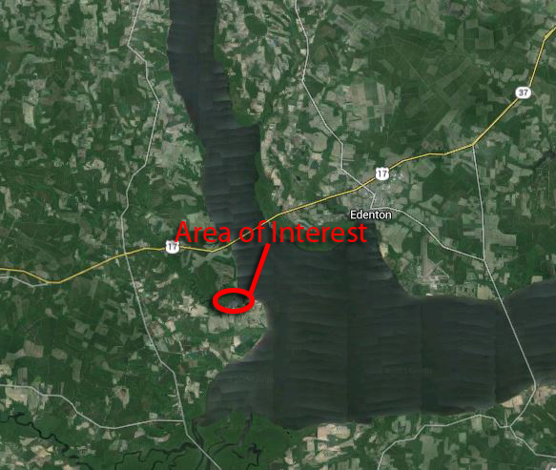
Fig. 1. Area of Interest located at the western extent of the Albemarle Sound [2].

Area of Interest (A.O.I)
Our Area of Interest (A.O.I.) is located at the western end of the Albemarle Sound near the conflux of the Roanoke and Chowan Rivers. Between these two major drainages is a drainage named Salmon Creek. The archaeological site selected for this study was previously identified in 2007 as the possible location of the Algonkian Village Metacuuem and noted by Elizabethan explorers in the Sixteenth Century. While not described in detail, the team had an idea of where it was located and how it may have looked from the watercolor map of John White who was the artist assigned to the expedition. White and later DeBry placed the village on the north side of a river or creek that is undoubtedly Salmon Creek (see Fig. 2). Previous archaeological studies suggest that the village was most likely palisaded (see Fig. 3) with a small population at or near 100 individuals.
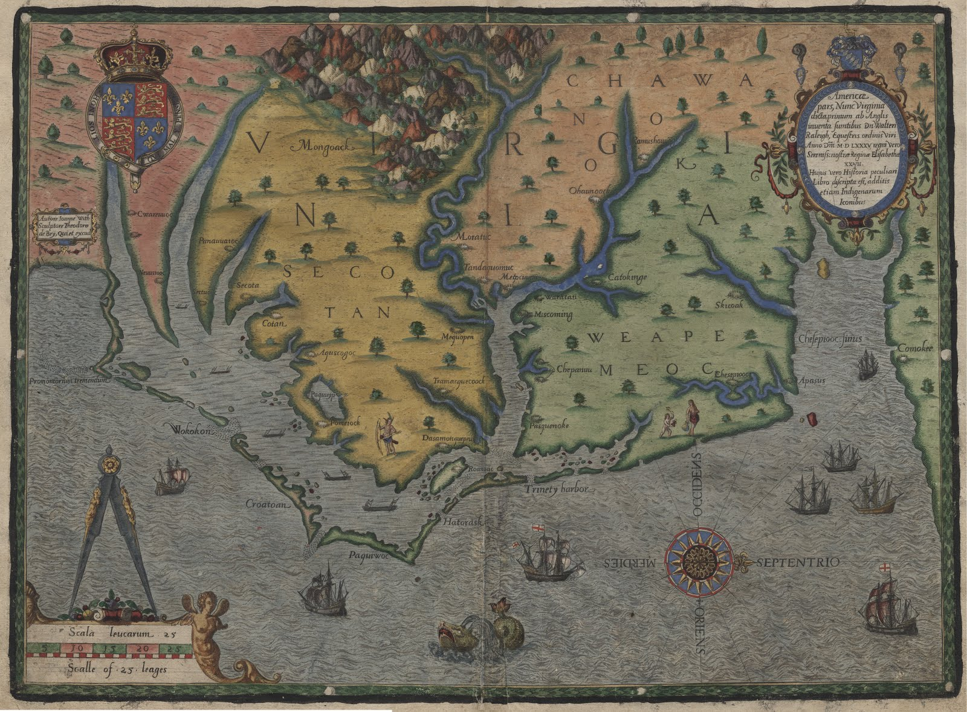
Fig. 2. Theodore de Bry woodcutting based on John White’s watercolor [3].

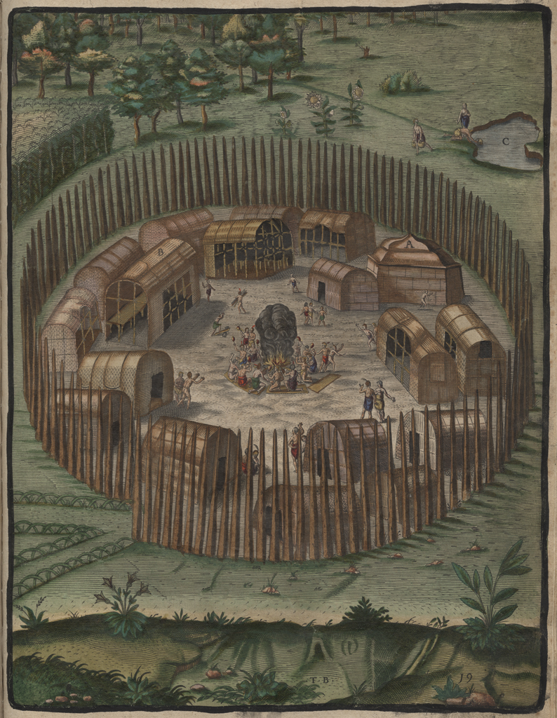
Fig. 3. The village of Pomieoc [4].
Fig. 4. Broken Pottery visible on the surface of site 31BR264.
In 2007 archaeologists identified the probable location of Metacuuem, a 16th century Native American village, located in a set of agricultural fields just north of Salmon Creek. The field where this site is located possesses hundreds of pottery shards on the surface relating to the time period, like those seen in Fig. 4.

Equipment
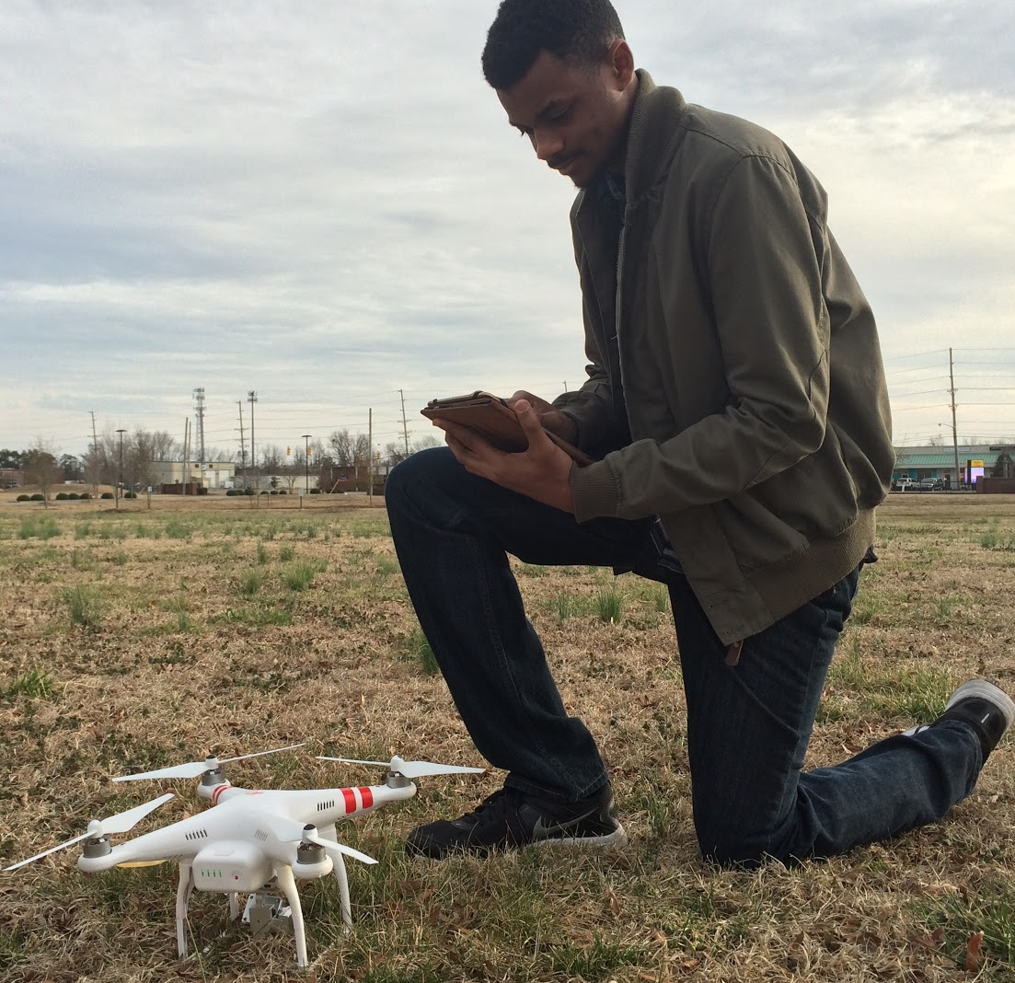
Fig. 5. DJI Phantom 2 Vision+ U.A.V.
The primary piece of equipment used to conduct this research was the DJI Phantom 2 Vision+ U.A.V. with a built-in Naza-M V2 Flight Control System and integrated gimbal and camera (Fig. 5) [1]. The Phantom 2 Vision+ is a two pound remote-controlled quadcopter that contains four rotating wings capable of stable flight and taking high resolution pictures and video.
The video is captured at 1080 pixels/30 frames per second and 720 pixels/60 frames per second, and contains the option for the user to shoot slow motion video [1]. The JPEG type photos taken at 14 megapixels are captured by the camera operated on a stabilizer, which is a benefit that eliminates unsteady video and images caused by the four motors. The U.A.V. can operate autonomously or with minimal pilot training, fly at and up to 1000 ft. in calm wind and as fast as 15 meters/second with the four basic directions of flight pitch (forwards and backwards), roll (left and right), elevator (up and down) and yaw (turn left or right) [1]. The DJI has a built-in inertial sensor and a barometric altimeter that measures both attitude and altitude. Also, the quadcopter operates on a flight time of approximately 25 minutes [1]. In retrospect, the DJI Phantom 2 Vision+ U.A.V. turned out to be very cost effective and versatile regarding its numerous functions and uses.
In retrospect, the DJI Phantom 2 Vision+ U.A.V. turned out to be very cost effective and versatile regarding its numerous functions and uses.

Developing a Flight Plan
The autonomous flight feature of the DJI Phantom 2 Vision+ U.A.V. makes it an attractive platform for flying linear transects that allow image overlap (Fig. 6). This overlap is necessary for the creation of the larger mosaic. Despite the U.A.V.’s ability to fly missions on its own, it is still necessary to plot the linear transects prior to flight. It is also important to plot out the mission onsite as obstacles such as trees and power lines pose a threat to successful flight operation. Prior to flying, the team chose a location free of obstacles for take-off and oriented the transect grid over the A.O.I.
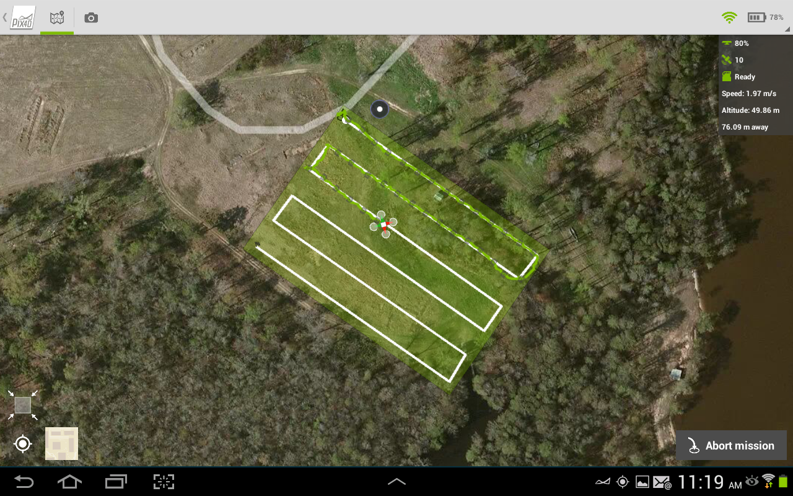
Fig. 6. Map demonstrating orientation and extent of transects as well as route of U.A.V.

Image/Image Processing
In order to process the images captured by the DJI Phantom’s visible light camera, the team generated a photo mosaic as an effective way of analyzing the field data collectively. The term photo mosaic refers to one complete image that is formulated by the piecing together of multiple images. The images taken during the flight along the transects were composed into a photo mosaic using the image processing software Pix4D, which converts a multitude of images into "geo-referenced 2D mosaics and 3D models", useful for mapping and modeling (Fig. 7) [5]. A 64-bit trial version of Pix4D Mapper (Pro Version) for Microsoft Windows 7 was downloaded to a 4GB HP Portable Computer. The 87 images collected and stored as JPEG on SD cards provided with the DJI Phantom were transferred to a Samsung 10.2 tablet. From that point forward, the images were inserted into the Pix4D Mapper application project folder. Then the software took the individual images taken along the transects, determined the overlap between each image by searching for commonalities, and then composed the images collectively into a 3D photo mosaic model of the Salmon Creek site.
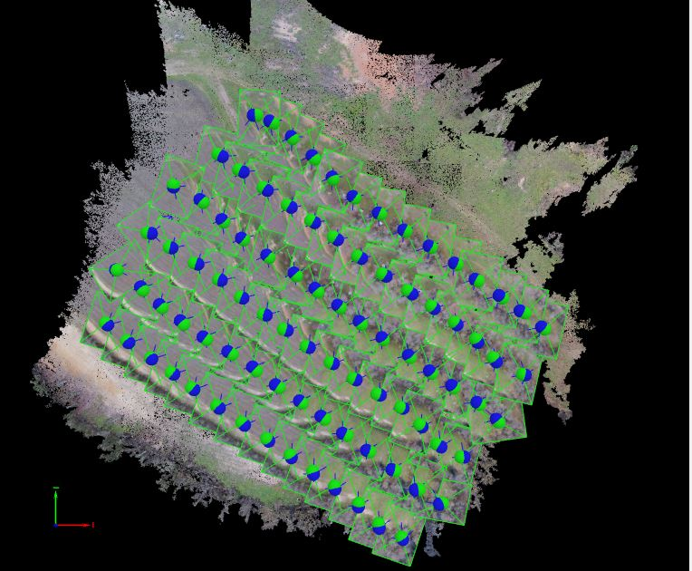
Fig. 7. Overlap in the aerial imagery. Each dot represents an image taken by the U.A.V. (87 total).

Selecting the Pix4D software for image processing proved to be a great benefit for the team. By downloading the software, Pix4D provided an application for mobile devices that was used in the field to map transects for the automated flight. Once transects were mapped, the U.A.V. automatically flew at a constant elevation of 50 meters along the route taking aerial images at every point mapped until completion. This resulted in 87 overlapping images that would later be used to produce a larger mosaic image and 3D point cloud. The benefit of this automation was that the team did not have to manually fly the U.A.V. Manual flight of the U.A.V. could have resulted in various elevation changes throughout flight due to the strain of manually trying to make the elevation constant and the chance of over-mapping as well as under-mapping transects points, which could have produced an unreliable geo-referenced photo mosaic of the surveyed area.

Analysis
In aerial archaeology, crop marks are a means of revealing what lies underneath the surface of the ground. Crop marks are formed by variations in the subsoil, which can be caused by buried archaeological features, such as bricks and other various items or structures which cause differential crop growth [6]. Sunlight, particularly early or late in the day when the sun is low in the sky, can cast a very clear shadow over the different crop heights, revealing the shape and size of buried archaeological features which would be difficult to see when the sun is high in the sky. Crop marks are best observed when the soil in the area is dry rather than wet because dry soil can dramatically affect how crop marks look and can help to clearly show the differences. This means that very dry summers are often the best time to view crop marks.
Our analysis of imagery from this survey reveals several such marks we feel should be investigated further. While a few of the anomalies discovered in the area are the direct result of previous archaeological studies, their presence in the imagery suggests that ground disturbing features such as these are easily identifiable under the correct conditions. Two anomalies discovered in the images have not been identified before (Fig. 10), and will require inspection as well as testing in the field to understand what they represent. Archaeologists call this action Ground Truthing. Three images are presented here, the first represents visible light with no alteration of the image (Fig. 8) the second is contrast enhanced (Fig. 9), and the third represents faked IR (red channel is emphasized) (Fig. 10).
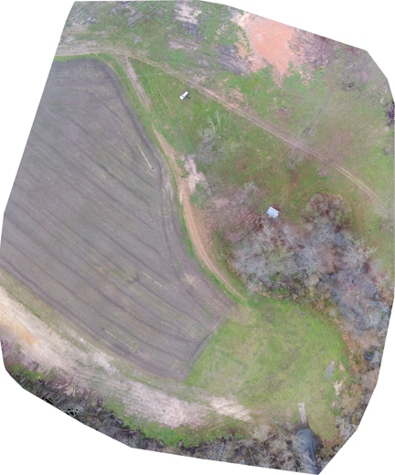
Fig. 8. Visible light photo mosaic of surveyed area.
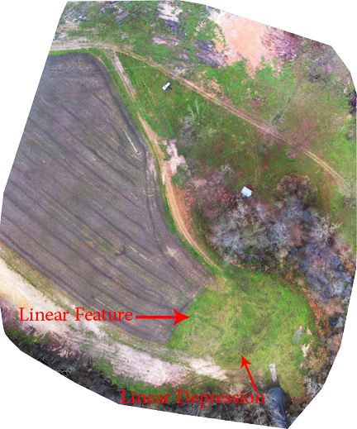
Fig. 9. Contrast enhanced mosaic of surveyed area.
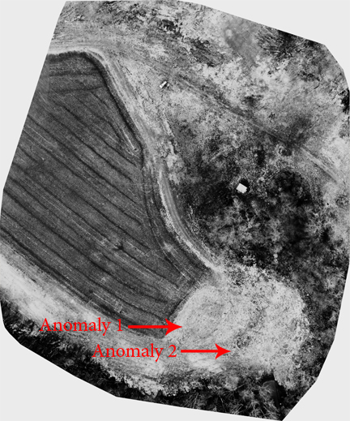
Fig. 10. Faked IR mosaic of surveyed area.

Linear Feature
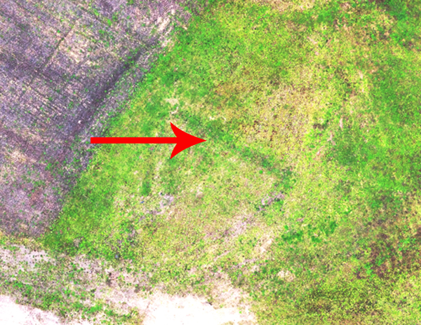
Fig. 11. Linear feature representing a 2007 archeological trench.
This feature seen in Fig. 11 is best described as a positive crop mark. It is linear, oriented roughly north/south, and represents one of several trenches excavated by archaeologist in 2007. The trenches were filled back in several years ago, yet their outline is clearly visible in the contrasting green vegetation. The ease in which we relocated this trench during our study demonstrates the major concept of how variations in vegetation color and type denote subsurface features. In this instance, a linear trench was cut to an approximate depth of one foot below the surface and then refilled after inspection. The fill inside the trench is looser than the surrounding soil allowing the roots of the vegetation to penetrate deeper--- producing healthier plants, in this case richer greener vegetation.

Anomaly 1
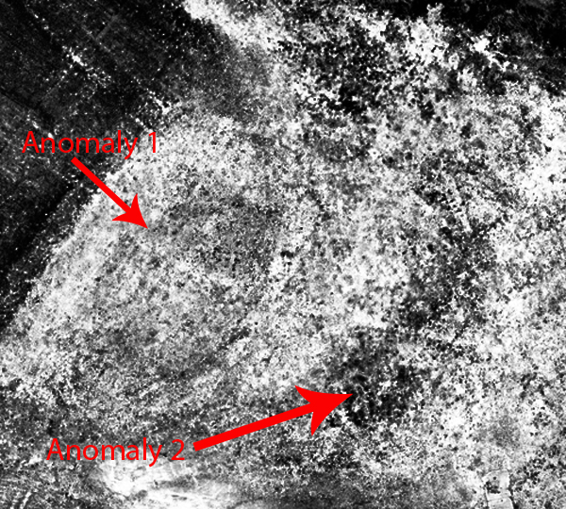
Fig. 12. Anomalies 1 and 2 present in this faked IR Image created by dropping out blue and green channels.
The large oval feature in Fig. 12 is only visible in the faked IR image. Its dimensions are roughly 60 feet by 45 feet oriented east/west. The linear feature, or the 2007 trench, cuts directly through its center. It is not obvious whether Anomaly 1 is related to the 2007 trench, but its shape and form suggest it is not. Unlike the more vibrant green from plants a top the 2007 trench, plants within the radius of Anomaly 1 are sparse. This suggests that more compact soils are inhibiting plant growth where shallow roots are unable to reach looser more moist soils. It is possible that this feature represents an area around a habitation site or home. In such areas soils are compacted from trampling or the disposal of refuse around the perimeter of a structure. Note the darker black band around the perimeter of the feature. While its size appears to be larger than the typical longhouse seen in the Pomeioc image (Fig. 4), it is possible that one large house or multiple small houses are represented by this anomaly. The team recommends future studies that focus attention on determining the identity of this anomalous feature.

Anomaly 2 (Linear Depression)
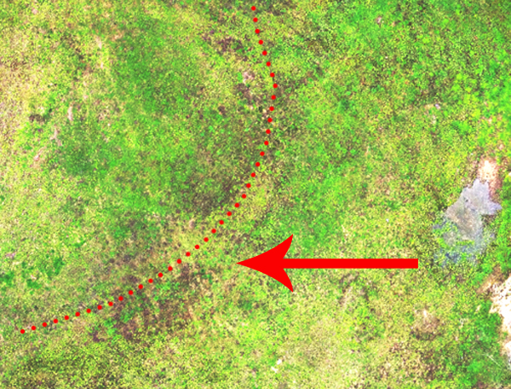
Fig. 13. Linear depression probably the result of modern activity.
The Linear Depression or Anomaly 2 in Fig. 13 is present in all three supplied images. Its origin however is unknown and may be the result of recent alterations to the boat ramp access just east of its location. It should be stated that the depression runs towards the eastern wetlands area separating archaeological site 31BR246 from 31BR168. The darker coloring of this feature suggests that it is saturated from an overly wet winter. Standing water can be seen in Fig. 13 just to the right of the feature. It can be said with certainty that the linear depression is manmade; however, just exactly when will require additional testing. Therefore the team recommends that archaeologists evaluate the date of its creation through excavation. There is a chance that this feature represents a ditch associated with the Indian village, Metacuuem.

conclusion
Research was successful in that the team achieved the primary and secondary objectives which were to test, develop, and acquire the needed technology to make use of the images taken through the U.A.V. platform, in addition, produce a data set that archaeologists could use in future studies. By evaluating the Salmon Creek site in Bertie County, North Carolina with the DJI Phantom 2 Vision+, 87 images were captured and stitched together to generate a dense surface photo mosaic using Pix4D software. Use of this software revealed aspects that had not quite been identified by archaeologists in 2007. The two anomalies discovered, shown in Fig. 12 expose possible man-made features, linear depressions, and crop marks. It is highly recommended that because this research has produced practical data sets, archaeologists from this point forward have reason to return to the excavated site and continue further inspection in order to identify the features found through Ground Truthing. Ultimately, the CERSER program at Elizabeth City State University can benefit from this research by applying U.A.V. technology and the methodology produced from this research to aid remote sensing and archaeological studies.

Acknowledgment
The team wishes to recognize Clay Swindell for his guidance, contributions, and help with completing this research. Also, the team acknowledges Dr. Linda Hayden for the research opportunity that was made possible through the CERSER program, Dr. Malcolm LeCompte for supplying the DJI Phantom 2 Vision+, and Michael Flannely for access to the Salmon Creek property. Without any of these individuals this project would never have succeeded.

References
- Phantom 2 Vision+ User Manual, V1.6, DJI Co., Los Angeles, CA, 2015, pp. 5-12.
- Digital globe, USDA Farm Service Agency Map Data (2015). Google Maps [Online]. Available: https://www.google.com/maps
- Joyner Library, East Carolina Univ. (2010). Roanoke colonies illuminated [Online]. Available: https://digital.lib.ecu.edu/hakluyt/view.aspx?p=Island%20of%20Roanoak&id=1390
- A. Lamb. (2013-2015). The book: 1450 to the present [Online]. Available: http://eduscapes.com/bookhistory/artifact/6.htm
- Pix4D Co. (2015). Pix4D: simply powerful [Online]. Available: https://pix4d.com/
- S.A. Aqdus et al, “Discovering archeological cropmarks: a hyperspectral approach,” Dept. Geographical Earth Sciences, Univ. Glasgow, Glasgow, UK, Rep. G12-8QQ, 2008.

